class05.R

codyhargadon

2021-10-12

# 'title: "Class 05 Data Visualization"  
# 'author: "Alexis Cody Hargadon, A15479290"  
# today's objective: learn how to use ggplot(), aes(), and geom_point()  
#used plot type determined by type of variable:  
 #continuous numeric: measured data, can have infinite values within possible range  
 #discrete categorical: observations can only exist at limited values, often counts  
library(ggplot2)  
cars

## speed dist  
## 1 4 2  
## 2 4 10  
## 3 7 4  
## 4 7 22  
## 5 8 16  
## 6 9 10  
## 7 10 18  
## 8 10 26  
## 9 10 34  
## 10 11 17  
## 11 11 28  
## 12 12 14  
## 13 12 20  
## 14 12 24  
## 15 12 28  
## 16 13 26  
## 17 13 34  
## 18 13 34  
## 19 13 46  
## 20 14 26  
## 21 14 36  
## 22 14 60  
## 23 14 80  
## 24 15 20  
## 25 15 26  
## 26 15 54  
## 27 16 32  
## 28 16 40  
## 29 17 32  
## 30 17 40  
## 31 17 50  
## 32 18 42  
## 33 18 56  
## 34 18 76  
## 35 18 84  
## 36 19 36  
## 37 19 46  
## 38 19 68  
## 39 20 32  
## 40 20 48  
## 41 20 52  
## 42 20 56  
## 43 20 64  
## 44 22 66  
## 45 23 54  
## 46 24 70  
## 47 24 92  
## 48 24 93  
## 49 24 120  
## 50 25 85

#every ggplot had a data + aes + geom  
ggplot(data=cars) +  
 aes(x=speed, y= dist) +  
 geom_point() +  
 geom_smooth()

## `geom_smooth()` using method = 'loess' and formula 'y ~ x'

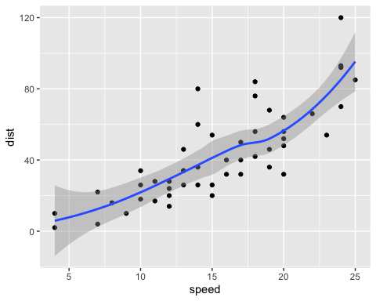

#change to a linear model  
p <- ggplot(data=cars) +  
 aes(x=speed, y= dist) +  
 geom_point() +  
 geom_smooth(method = "lm")   
#can call p to make plot now   
p

## `geom_smooth()` using formula 'y ~ x'

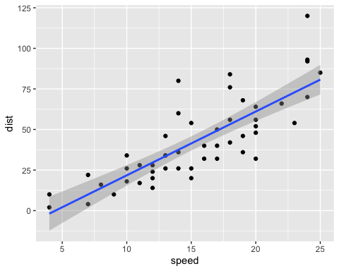

p +labs(title= "plot",  
 subtitle="mm cars",  
 x= "speed",  
 y= "distance")

## `geom_smooth()` using formula 'y ~ x'

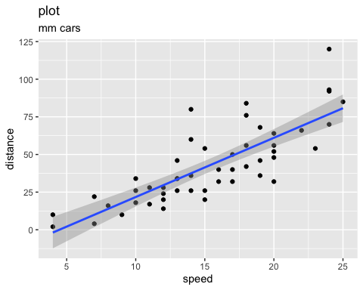

#base graphics is shorter  
plot(cars)

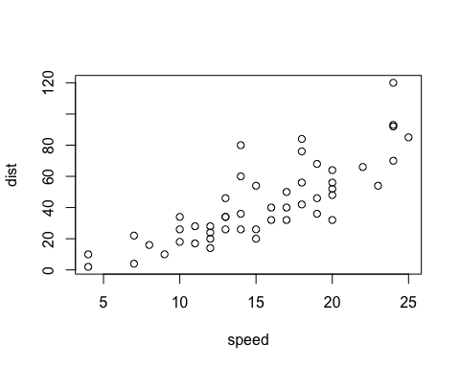

url <- "https://bioboot.github.io/bimm143_S20/class-material/up_down_expression.txt"  
genes <- read.delim(url)  
head(genes)

## Gene Condition1 Condition2 State  
## 1 A4GNT -3.6808610 -3.4401355 unchanging  
## 2 AAAS 4.5479580 4.3864126 unchanging  
## 3 AASDH 3.7190695 3.4787276 unchanging  
## 4 AATF 5.0784720 5.0151916 unchanging  
## 5 AATK 0.4711421 0.5598642 unchanging  
## 6 AB015752.4 -3.6808610 -3.5921390 unchanging

nrow(genes)

## [1] 5196

colnames(genes)

## [1] "Gene" "Condition1" "Condition2" "State"

ncol(genes)

## [1] 4

table(genes$State)

##   
## down unchanging up   
## 72 4997 127

#fraction of genes upregulated, answer with 2 significant figures  
round( table(genes$State)/nrow(genes) *100, 2)

##   
## down unchanging up   
## 1.39 96.17 2.44

127/5196

## [1] 0.02444188

g <- ggplot(data=genes) +   
 aes(x=Condition1, y=Condition2, col=State) +  
 geom_point()  
g+ scale_color_manual(values= c("cyan", "orangered2", "seagreen2")) + labs(title= "Gene Expression Upon Drug Treatment", x="Control (no drug)", y="Drug Treatment")

